**TITLE OF PROJECT**

**LOCAL FINDER**

**A Mini-Project Report**

**Under**

**Implementation of Technology**

***Submitted by***

***Yogesh k Yadav (B047)***

***Nimesh Panchal (B057)***

***Pratik Telang (B060)***

***Prakhar Goyal (B063)***

***In partial fulfillment for the award of the degree***

**B.Tech.**

**IN**

**Computer Science**

**At**



**Mumbai,**

**April 2015**

**CERTIFICATE**

This is to certify that the project entitled **LOCAL FINDER** is the confide work carried out by **PRAKHAR GOYAL, PRATIK TELANG, NIMESH PANCHAL, YOGESH K YADAV** B.Tech (Computer Engineering), MPSTME (NMIMS), Mumbai, during the fourth semester of the academic year 2014-2015, in fulfillment of the requirements for the award of the Degree of Bachelors of Technology as per the norms prescribed by NMIMS. The project work has been assessed and found to be satisfactory.

_______________________ ________________________

Examiner 1 Examiner 2

________________________

Dean

Dr. S.Y. Mhaiskar

**DECLARATION**

We, **PRAKHAR GOYAL, PRATIK TELANG, NIMESH PANCHAL, YOGESH K YADAV** B.Tech (Computer Engineering), semester- IV, understand that plagiarism is defined as anyone or combination of the following:

1. Un-credited verbatim copying of individual sentences, paragraphs or illustration (such as graphs, diagrams, etc.) from any source, published or unpublished, including the internet.

2. Un-credited improper paraphrasing of pages paragraphs (changing a few words phrases, or rearranging the original sentence order)

3. Credited verbatim copying of a major portion of a paper (or thesis chapter) without clear delineation of who did wrote what.

4. We have made sure that all the ideas, expressions, graphs, diagrams, etc., that are not a result of our work, are properly credited. Long phrases or sentences that had to be used verbatim from published literature have been clearly identified using quotation marks.

5. We affirm that no portion of my work can be considered as plagiarism and we take full responsibility if such a complaint occurs. We understand fully well that the guide of the seminar/ seminar report may not be in a position to check for the possibility of such incidences of plagiarism in this body of work.

Name: YOGESH K.Y. NIMESH P. PRATIK T. PRAKHAR G.

Roll No. B047 B057 B060 B063

Signature

Of the

Students: ___________ ____________ ___________ ____________

Place: Mumbai

Date: April 2015

**ACKNOWLEDGEMENT**

We would like to express our special thanks of gratitude to our teacher Ms. Poonam Gupta for giving us this opportunity to work on this wonderful project. She was very supportive and motivated during the entire course of this project. She made sure that we don’t lose our track by giving us important inputs like video tutorials, notes, etc. and always helped us. During the project we come across many new concepts that we were not aware of and hence working on this project under the guidance of mam proved to be very fruitful. We would also like to thank our friends who have helped us in this project. Also we would like thanks our dean Mr. Sharad sir and computer science head of department Mr.Dhirendra Mishra sir for their innovative thinking of involvement of this course in our syllabus.

**Table of Content**

**LIST OF FIGURES: 9-12**

1.) Figure 3.1.1 Page 1 of app

2.) Figure 3.2.2 Page 2 of app

3.) Figure 3.2.3 Page 3 of app

4.) Figure 3.2.4 Page 4 of app

# **1. Introduction** **6**

## 1.1 Problem Specification

## 1.2 Solution Outline

## 1.3 Application/Usage

# 2. System Analysis **7**

## 2.1 Existing System (If any)

## 2.2 Software Requirement

## 2.3 Hardware Requirement

# 3. Design and Methodology **8-12**

## 3.1 Flowchart of App

## 3.2 Output (Screenshot of the app)

## 3.3 Limitation of App

# 4. Conclusion and Future Scope **13**

# 5. References **13**

**1. Introduction:**

**1.1 Problem Specification:**

In this ever growing world we need something to guide from where to avail the commodity, as every person may reach to an area but he might not know where is that facility available.

For Example: A person owning a car and coming all the way from Thane, Maharashtra to Andheri, Maharashtra he might not know where are the parking locations or fuel stations of this area.

**1.2 Solution Outline:**

To resolve this issue we thought of building an app wherein all such local issues can be resolved.

**1.3 Application/Usage:**

Local finder is created with the whole new idea with the intent to help people to find parking places.

Fuel stations and various other commodities in an instant as with the growing landscape every person can`t remember where to avail these commodities, thus having our app makes the life of the user much simpler.

At this stage of development with a user given pin code it will display various commodities available with our app and then thereafter when the user selects the commodity ,the app will display the various locations from where the user can avail that commodity in that area which is as per the pin code mentioned by the user.

Unique feature of our app “local finder” is that it has a completely offline database therefore it makes the user to easily access the app and find the location of that commodity even with poor or no internet connectivity.

**2. System Analysis:**

## **2.1 Software Requirement:**

## The software required for the current application is

## Minimum android version 2.2 (Froyo).

## Preferred android version 5.0.2(Lollipop)-for material design implementation.

## .

## **2.2 Hardware Requirement:**

## The hardware required for the current application is

## Application storage space 5 MB.

## RAM requirement 35 MB.

## MUST provide at least one soft keyboard implementation .It requires a proper working touch keypad.

## Sensitive touch screen with minimum of 240 pixel width and 320 pixel height.

## Minimum kernel version- Linux kernel 2.6.32.

**Design and Methodology:**

## **3.1 Flowchart of App**

START

CLICK ON THE LOCAL FINDER APP

ENTER AREA PIN CODE

SELECT COMMODITY

**FUEL**

DISPLAYS LOACTION OF FUEL STATIONS IN THAT AREA

**PARKING**

DISPLAYS LOACTION OF PARKING PLACES IN THAT AREA

STOP

## **3.2 Output (Screenshot of the app):**

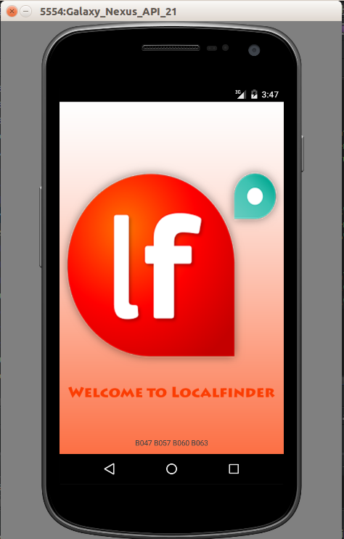

**Fig 3.2.1**

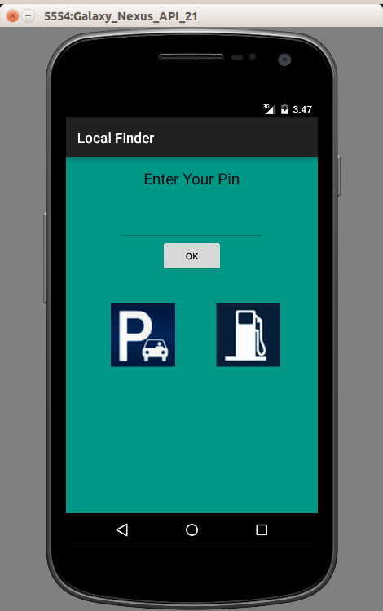

**Fig. 3.2.2**

**Parking Locations:**

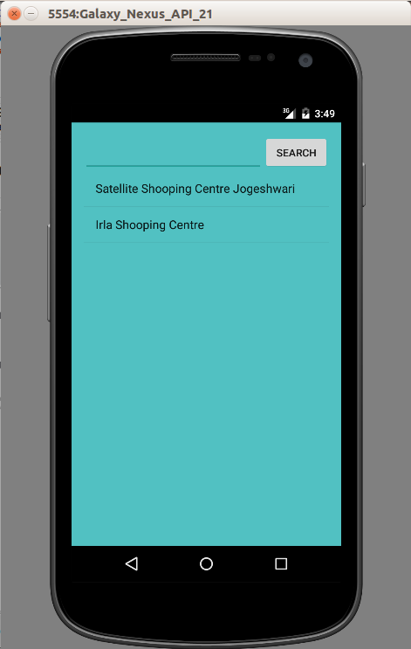

**Fig. 3.2.3**

**Fuel Stations:-**

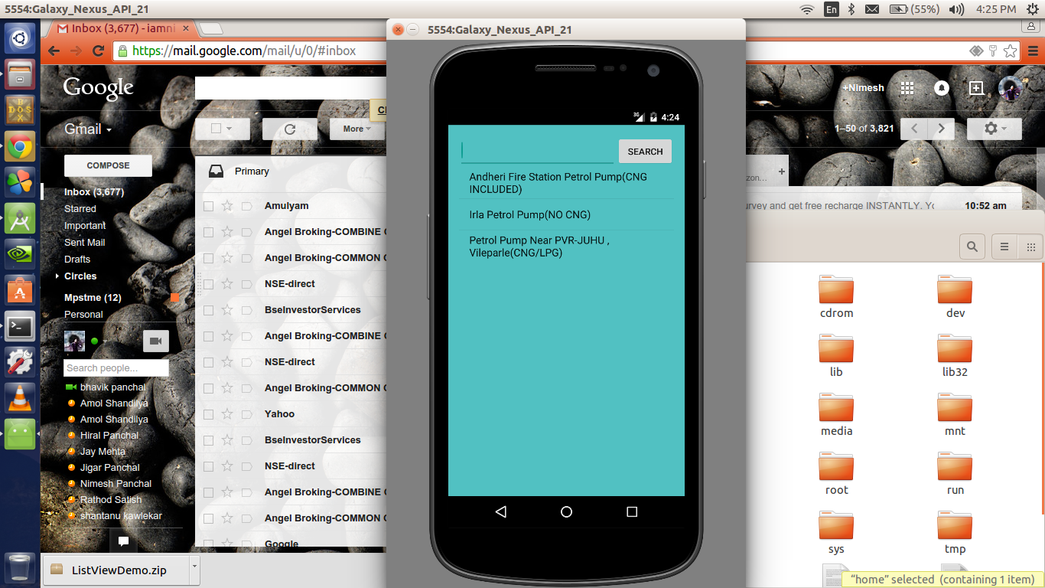

**Fig.3.2.4**

## **3.3 Limitation of App**

1. As the app is offline whenever the database is updated the user needs to download the updates so as to update the internal database of the app.

2. As the app is offline the size of the app gets increased depending on the size of the data.

**Conclusion:**

As m-indicator app (developed by IIT-B) helps people to find out buses, trains etc., from one stop to other. With this app we tried to help people to find out parking places, fuel stations of places like Andheri, Ville Parle.

**Future Scope:**

Currently user can search within the limitations of Ville Parle and Andheri. But in future we are planning of incorporating the whole city of Mumbai, and thereafter India.

We would also add more functionality like:-

HOSPITAS: Like in case of any emergency if someone gets injures then he/she needs hospitals through our app they may find it easily and quickly contact to hospitals Emergency ward.

ATM: The most important problems which peoples find when they travel from one city to another is where to find ATM nearby?

Therefore seeing their difficulties we will include the list of nearby ATMs for benefits of APP user.

PUBLIC LIBRARY: people fond off reading the novels, historic books, biography or any such kind of books they may find it through or app.

TOURIST PLACE IN CITY: This is one of the most important things searched on google and even google itself doesn’t show all the local visiting places for so through our app they may enjoy the tourist places.

BLOOD BANK: In case of emergency.

Our APP is currently offline, this limits the amount of data that can be accessed and also increases the size of the APP,

Thus for this we are going to integrate online databases to further increase the usefulness of our app.:

**References:**

***1. developer.android.com/sdk***

***2.*** **https://developer.android.com/training/basics/firstapp**

**3.** [**www.codelearn.org/android-tutorial**](http://www.codelearn.org/android-tutorial)

**4.** [**www.thenewboston.com**](http://www.thenewboston.com)